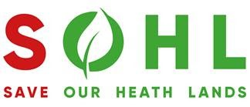

PLEDGE FORM
I/We the undersigned hereby pledge the sum of money detailed below, as a financial contribution towards the ongoing costs associated with the legal representations at the Government Inspector hearings or any further legal stages necessary through the course of 2023/2024. This pledge will expire on 30th June 2024. It is made without condition and in the name of Save Our Heath Lands (SOHL) for the purpose of protecting Lenham and the surrounding villages from Maidstone Borough Council’s “Heathlands” proposal.
Name of donor/donors :
Contact email :
Address :
Tel/mobile:
Total pledge amount (£500 minimum) :
Confirmation of 20% initial payment amount (£) :

Signed:
Date:

